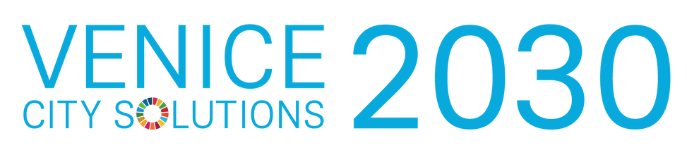



**SDGs SOLUTIONS TO RETHINK THE CITY**

2 AND 3 DECEMBER 2021

LOGISTIC NOTE

Madame, Sir,

We are delighted to count on your presence in Venice and your participation to the Venice City Solutions

Please find below some practical and useful information.

HOW TO REACH VENICE

<https://www.veneziaunica.it/en/content/getting-there>

**BY AIR**

Two airports deserve the city of Venice.

1. Marco Polo Airport, **code VCE**. International flights and European connections. [See destinations](https://www.veniceairport.it/en/#destinazioni-tab)
2. Treviso airport, **code TSF** where most low-cost companies operate. [See destinations](https://www.trevisoairport.it/en/#destinazioni-tab)

**BY TRAIN**

The city is also accessible by train, arriving to Venezia Santa Lucia train station, from Milan (2,5 hours), Bologna (1,5 hours) or Rome (3,5 hours). Please do not confuse with Venezia Mestre, that is not in the island but in the city of Mestre, out of Venice. More info and bookings: [Trenitalia](http://www.trenitalia.com/)

FROM THE AIRPORT AND THE TRAIN STATION TO VENICE

**FROM MARCO POLO AIRPORT**

There are several options to reach Venice from the airport. We recommend the use of the Alilaguna water bus, as it will take you close to your hotel, while the taxi or bus will only take you to Piazzale Roma, the last point in Venice that cars can reach.

The water bus service from the airport is provided by the company [Alilaguna](http://www.alilaguna.it/en). Once you have land in Venice Marco Polo, please exit at the Arrivals Hall, and look for the covered walkway on your left indicating “WATER BUS”. Follow the walkway for 7 minutes until you reach the dock.

Please check [times and routes](https://www.alilaguna.it/en/lines/line-timetables) before departing

There are several lines (see map below)

Journey time: Fondamenta Nove (38 minutes), Lido (58 minutes), San Marco (1 hour and 12 minutes), Rialto (57 minutes), Guglie (42 minutes).

Fares - One way 15 euro, Return 27 euro.

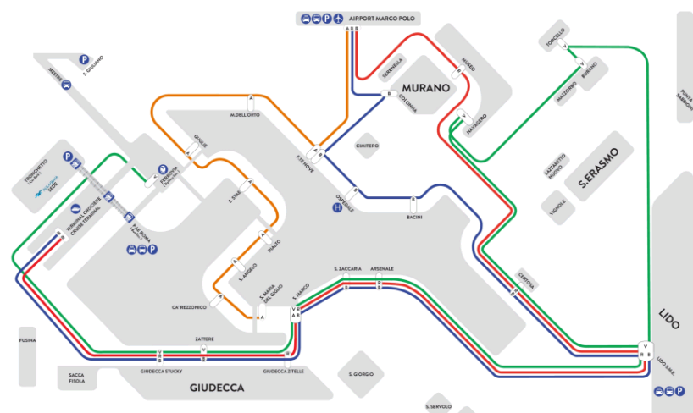

**

To Piazzale Roma, a 5-minute walk from the Venezia Santa Lucia railway station. Beware than from the train station either you must walk up and down the bridges (which can be a problem carrying luggage) or either take a water bus (or vaporetto).

* [ACTV](http://www.actv.it/en) Urban line 5.
* [ATVO](http://www.atvo.it/) VENEZIA EXPRESS Shuttle

Journey time to Piazzale Roma: about 28 minutes.

[Complete bus information](https://www.veniceairport.it/en/transport/bus_42.html)

**BY TAXI TO PIAZZALE ROMA**

The taxi service is provided by [Cooperativa Artigiana Radiotaxi](http://www.radiotaxivenezia.com/en/). For info and bookings Tel. +39 041 59 64 (24-hour service).

**

**BY BUS**

* [ATVO](http://www.atvo.it/index.php?lang=en) line to Piazzale Roma.

**BY TAXI (40 minutes approximately to Piazzale Roma in Venice)**

The service is provided by the company [Radio Taxi Treviso](http://www.taxitreviso.it/home/). For info and bookings: Phone:  +39 0422 431515 Text: +39 338 844 2000

**BY TRAIN – Santa Lucia Train Station**

Once arrived to Venezia Santa Lucia Station, either walk or take a water boat (vaporetto). See more information below about “How to move in Venice”. The train station is also commonly signed by its Italian name “FERROVIA” and many indicators can be found in the streets for direction.

**MOVING WITH HEAVY LUGGAGE**

If you are travelling with a lot of bags, we advise to contract a service to move it from your point of arrival to your hotel, since it is very possible that you need to walk quite a lot with public transportation and the city has a big number of bridges to be crossed with numerous stairs.

[On-line bookings for transferring luggage](https://www.trasbagagli.it/en/main)

MEETING VENUE

The meeting will take place at the

**BAUM Library of Ca’ Foscari University**, <https://www.unive.it/pag/13526>

The address is:

**Palazzo Malcanton Marcorà - Dorsoduro 3484, Venice**

he site is 50 metres from Santa Margherita square, that is 10 minutes’ walk from Piazzale Roma.

Venice is not a simple city, as orientation can be at times difficult. Please allow plenty of time to arrive to the meeting opening on time, as getting lost is always a possibility in Venice.

Biblioteca Area Umanistica - BAUM - Ca' Foscari

[Palazzo Malcanton Marcorà - Dorsoduro 3484, D, 30123 Venezia VE](https://www.google.it/maps/place/Biblioteca+Area+Umanistica+-+BAUM+-+Ca'+Foscari/@45.4348042,12.3218485,3a,91.3y,90t/data=!3m8!1e2!3m6!1sAF1QipP_Ek-EHnxo0gGYhCDdz7bSYUJY5HKWwQOMGLSc!2e10!3e12!6shttps:%2F%2Flh5.googleusercontent.com%2Fp%2FAF1QipP_Ek-EHnxo0gGYhCDdz7bSYUJY5HKWwQOMGLSc%3Dw397-h298-k-no!7i800!8i600!4m10!1m2!2m1!1sCa+Foscari+centro+studi+arte+russa+venezia!3m6!1s0x477eb1c8e7a1a2cd:0xcad56579bc5bf5ec!8m2!3d45.4348042!4d12.3218485!14m1!1BCgIgARICEAE?hl=it&authuser=0)Immagine che contiene mappa

MOVING AROUND VENICE

Is important to know the times of the vaporetti (or water buses) to plan travel ahead. An online travel planner is available at <http://muoversi.venezia.it/en>

You can also find a map of the route map here. Is important to study the numbers of the routes and times from your hotel in advance.

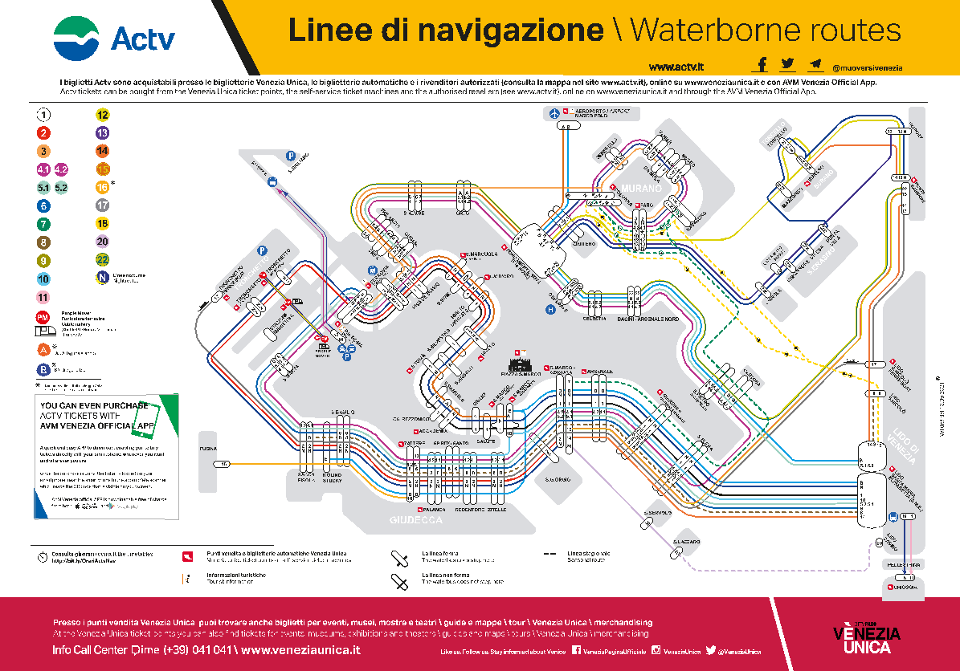

**PRICES**

The price for an individual ticket in the Vaporetto water bus is 8.00 euros, valid for 75 minutes from the moment of validation. One piece of hand luggage is included in the cost. The sum of its three dimensions must not exceed 150 cm.

We recommend to get a Day pass that can be obtained beforehand to avoid lines or penalties for boarding the boat without a ticket. You can purchase them online at

<https://www.veneziaunica.it/en/e-commerce/services>

**24 hours pass 20 euro** //

**48 hours 30 euro** //

**72 hours 40 euro** //

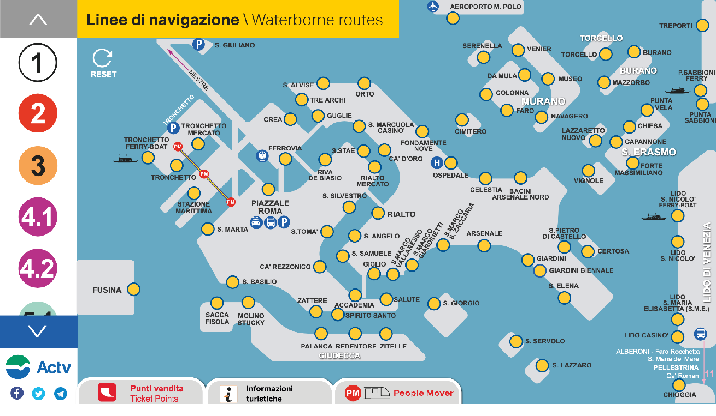

**WHERE TO BUY TICKETS**

AVM/Actv tickets can be purchased from the following sales channels:

• Venezia Unica point of sale throughout the historic center of Venice and on the mainland

• authorized retailers

• automatic ticketing machines at the main AVM/Actv public transport arrival terminals and waterbus stops

• AVM Venezia Official App

• on line on www.veneziaunica.it

• on board waterborne services

OTHER USEFUL INFORMATION

**Weather:** the month of December usually is not rainy, but can be humid in Venice.

• Maximum average: 10 ° C

• Minimum average: 0 ° C

**Safety:** Venice is a safe city. However, be aware of pickpockets in crowded places.

**Cultural agenda:** you can find useful information on the following links:

<http://www.agendavenezia.org/en/>

[https://www.getyourguide.it/](https://www.getyourguide.it/-l35/-tc132/?cmp=bing&campaign_id=326332110&adgroup_id=1245746890988131&target_id=kwd-77859331037151:loc-93&loc_physical_ms=1888&match_type=e&ad_id=%7bcreative%7d&keyword=musei%20civici%20venezia&ad_position=%7badposition%7d&feed_item_id=&placement=%7bplacement%7d&partner_id=CD951&msclkid=cd025d47ccef1c7646b9003f7ee6b232&utm_source=bing&utm_medium=cpc&utm_campaign=italy%3A29%7Ccore%7Cit%7Call&utm_term=musei%20civici%20venezia&utm_content=venice%3A35%7Cf4%7Cmuseums%20%26%20exhibitions%3A132%7Cmuseums%20%26%20exhibitions%3A1211%7C%7Btd21%7D%7C%7Byr16%7D)

<https://theculturetrip.com/?s=venice>

ACCOMODATION

Here the closest hotels from the meeting venue:

**NH VENEZIA RIO NOVO** **(20 metres from the venue)**

<https://www.nh-hotels.it/booking/step1-rates?fini=01/12/2021&fout=03/12/2021&nadults1=2&nchilds1=0&nbabies1=0&hotelId=ITVE.RIONO&divisa=&gvoucher=false#v=compact>

Calle Larga Ragusei Dorsoduro 3489/E-C, 30123 Venezia Italia

**HOTEL MORESCO (100 metres from the venue)**

<http://hotelmorescovenice.com>

Sestiere Dorsoduro, 3499 Fondamenta del Passamonte, VE +39 041 2440202SA

**HOTEL NANI MOCENIGO**

<https://www.hotelnanimocenigo.com>

Fondamenta Nani, 960

NTA MARGHERITA GUESTHOUSE

**LOCANDA SAN TROVASO**

<http://www.casantrovaso.com/>

Dorsoduro 1350  
30123 Venezia  
+39 041 2412215, Mob. 349 1253890

**SANTA MARGHERITA GUESTHOUSE**

<https://www.santamargheritaguesthouse.it/it/camere>

MEALS

**Thursday, 2nd Dec**

lunch at Bakarò, h. 12.30:

<https://www.bakarovenezia.com/menu/>

dinner at La Taverna di Baffo, h.20.30:

<https://www.tavernadabaffo.com/home/>

**Friday, 3rd Dec,**

lunch at Bakarò, h. 12.30:

<https://www.bakarovenezia.com/menu/>

Apericena at Osteria La Bifora:

<https://www.facebook.com/Osteria-Alla-Bifora-Pagina-Autentica-1842832212674624>

