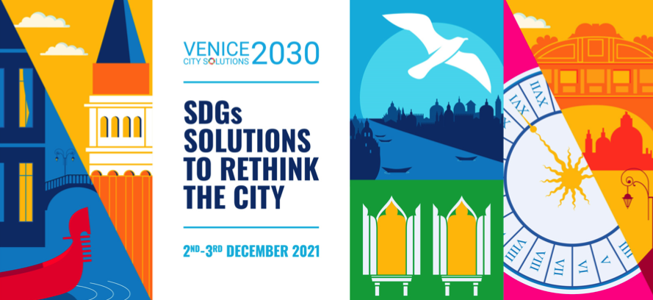

PROVISIONAL AGENDA

Thursday 2nd December
Link: https://us02web.zoom.us/j/84516341734?pwd=REg5ejNBMWxRTEZjVUVDcXV1SzRwZz09
Meeting ID: 845 1634 1734
Access code: 994028

Morning | Time for informal bilaterals | Venice room only
13.00 – 14.00 | Opening session  - Round of presentations  - Setting the agenda  - Objectives and methodology for the sessions | Venice room only
14.00 – 14.15 | Institutional welcome by the organizing institutions: UCLG, AICCRE, UN-Habitat, UNDP and UN SDG Action Campaign  - Video Aiccre | Zoom connection
14.15 – 15.30 | BLUE TRAIL – INCLUDING: ADDRESSING INEQUALITIES IN THE CITY  City focus: Bogota (Colombia), Diana Rodriguez Franco, Women’s affairs Councilor, City of Bogota  Respondents:  - Pilar Díaz, Deputy to the Presidency and Delegate for International, Relations of the Barcelona Provincial Government and Mayor of Esplugues de Llobregat - Local4Action HUB  - Emilio Rabasco, Director, Andalusian Municipal Fund for International Solidarity, FAMSI - Local4Action HUB  - Camila Cociña, Research Fellow, Knowledge in Action for Urban Equality (KNOW), The Bartlett Development Planning Unit, University College London  - Bahram Ghazi, Officer on Local Governments, Cities and Human Rights, UN Office of the High Commissioner for Human Rights (TBC)  - Stefano Vitali, Sustainable Finance Advisory Director at Unicredit Bank  - Massimo Renno, AEres Venezia, Italy  Reactions from the room in Venice  Moderates: Diana Lopez Caramazana, Partnership Specialist, Cities and Local Governments, UNDP | Zoom connection open to registered online participants  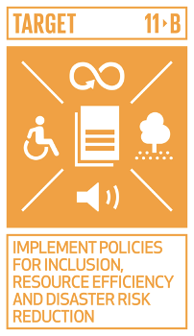
15.30 – 16.30 | SHARING IDEALS: THE ROLE OF CULTURE TO LOCALIZE THE SDGs  City focus:  - Serkan Nebioglu, Izmir (Turkey)  - Vladimir Ameller, Municipal Secretary of Planning, La Paz, Bolivia  Respondents:  - SHI Qi, Director of Center for International Friendship Cities, Xi'an Municipal Foreign Affairs OfficeXian, China - Local4Action HUB  - Marta Llobet, Learning and advocacy officer, UCLG Culture Committee, UCLG Committee on Culture  - Maria Radaelli, Centre for studies on Russian Art (CSAR), Ca’ Foscari University, Venice, Italy  - Elena Franco, Architect, Torino, Italy  Reactions from the room in Venice  Moderates: Carla Rey, Secretary General AICCRE | Zoom connection open to registered online participants  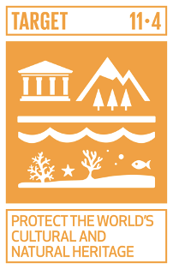
16.30 – 18.00 | Conversation with strategic UN partners:  - UN SDG Action Campaign - Remote connection with Marina Ponti, Director, UN SDG Action Campaign  - UN-Habitat - Martino Miraglia, Human Settlements Officer, SDG Localization Team  - UN-Environment - Martina Otto, Head of Cities and Lifestyles  - UNDESA - Daniel Platz, International Tax and Development Cooperation Branch, Financing for Sustainable Development Office  Facilitated by Emilia Saiz, Secretary General, United Cities and Local Governments | Venice room only

Friday 3rd December
Link: https://us02web.zoom.us/j/84516341734?pwd=REg5ejNBMWxRTEZjVUVDcXV1SzRwZz09
Meeting ID: 845 1634 1734
Access code: 994028

9.00 - 9.30  9.30 - 9.45  9.45 - 12.30 | Appointment in Caffe Rosso in Campo Santa Margherita  Walk to the meeting venue to enter as a group for security reasons  Venice Room only  - Sharing of information and actions by partners  - Common calendar of efforts for 2022  - What is next after year 2030?  - Drafting the Venice Recommendations to HLPF 2022 | Venice room only / No zoom
14.00 – 15.15 | YELLOW TRAIL – TRANSFORMING: A NEW SUSTAINABLE MOBILITY  City focus: Danane (Ivory Coast), Richard Seshie, Lead Africa Dunia Payment, Founder Cool Lion Africa  Respondents:  - Laura Ziliani, Advisor Directorate of Planning, Use and Evaluation. Secretariat of Transportation and Public Works, Buenos Aires, Argentina  - Mangesh Dighe, Environmental Officer, Municipal Corporation of Pune, India  - Dionisio Gonzalez, Director, Advocacy and Outreach at the International Association of Public Transport  Open Mic:  Bruno Lana, Economic Affairs Officer of the Sustainable Development and Human Settlements Division, Economic Commission for Latin America and the Caribbean  Reactions from the room in Venice  Moderates: David Jackson, Director, Local Transformative Finance, United Nations Capital Development Fund (TBC) | Zoom connection open to registered online participants  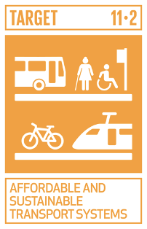
15.15 – 16.20 | GREEN TRAIL – PLANNING: USING SDGS TO PLAN CITIES  City focus: Barcelona (Spain), Miquel Rodriguez Planas, Commissioner for Agenda 2030.  Respondents:  - Laura Monzo, Strategic Planning Coordinator, Municipality of Canelones, Uruguay  - Nicolas Gharbi, International Advisor, Madrid, Spain - Local4action HUB  - Rosa Pavanelli, Director, Public Services International  Reactions from the room in Venice  Open mic (online)  - Patricia Miranda Menezes, Mayor's Office Agenda 2030 Focal Point, City of Barcarena, Brazil  Moderates: Aline Matta, Policy Analyst, OECD | Zoom connection open to registered online participants  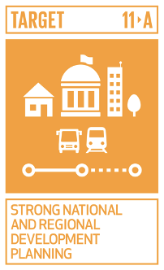
16.20 - 16.30 | What did we learn from the latest Global Task report to HLPF? Findings from “Towards the Localization of the SDGs, Sustainable and Resilient Recovery Driven by Cities and Territories”  Edgardo Bilsky / Cecile Roth, Research team, UCLG | Zoom connection open to registered online participants
16.30 – 17.30 | How cities are listening to deliver the common agenda: the UCLG Town Hall process  - Victor Pineda, Word Enabled  - Eugenie Birch, GAP  - Lorena Zarate, Global Platform for the right to the city (TBC)  Moderates: Emilia Saiz, Secretary General, United Cities and Local Governments | Zoom connection open to registered online participants
17.30 – 18.00 | Follow up discussion in the room and final agreement on HLPF Recommendations | Venice room only

