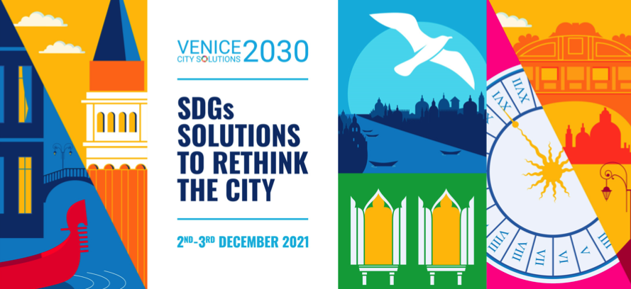

How cities are listening to deliver the common agenda: the UCLG Town Hall process
Friday 3rd December 16.30 – 17.30 CET

Link: https://us02web.zoom.us/j/84516341734?pwd=REg5ejNBMWxRTEZjVUVDcXV1SzRwZz09
Meeting ID: 845 1634 1734
Access code: 994028

Speakers:
- Victor Pineda, Word Enabled
- Eugenie Birch, GAP
- Lorena Zarate, Global Platform for the right to the city (TBC)

Facilitated by: Emilia Saiz, Secretary General, United Cities and Local Governments

INTRO
In line with the SDG Agenda and looking towards its final implementation, the United Nations Secretary-General’s Common Agenda report and its 12 areas of action provide a co-created vision on the future of multilateralism and strategies to reinvigorate it in the next 25 years by making it more inclusive, networked, and transformative. For this common agenda to be put into action and to truly reinvigorate multilateralism, it is clear to the constituency of local and regional governments that localization must be at the forefront of the agenda and that this can only be done with the full involvement of all spheres of government and all stakeholders.

The UCLG Town Hall is the space for dialogue and interaction between different internationally organized civil society constituencies, the political leadership of the local and regional governments constituency, and international partners to jointly define the global policies. Driven by civil society, this UCLG process allows different international stakeholders to collaborate in the definition of policy priorities and the localization of the global agendas. The policy recommendations commissioned for local and regional governments are a sign of the transformation of the municipal movement to include all stakeholders in the decision-making process and to showcase how cities are listening to deliver the UCLG’s Pact for the future.

Deeply connected with the Common Agenda, the Town Hall process will work towards defining how we will regain trust in governments and the public sector, redefining our institutions and governments, shaping the public services of the future, thinking about what will be part of the global commons for future generations, showing solidarity with the youth of tomorrow, moving towards community-led care systems and rethinking a just ecology.

This session will bring together different stakeholders included in the Town Hall process to start a debate on the key questions that will move this process forward to guarantee that cities are listening and driving the transformation towards the Common Agenda.

